Syllabus

My Professor

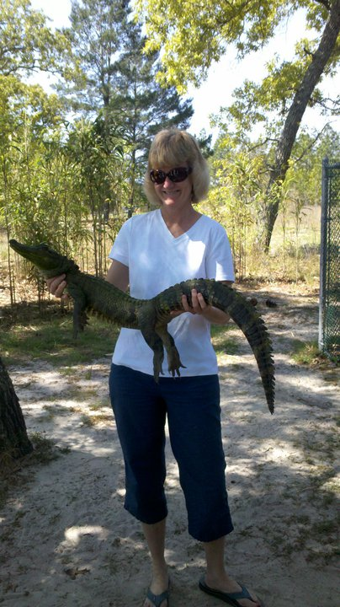
Robin Wilber, Ph.D.
Phone: (727) 341-3203
Fax: (727) 791-2441
Office: St Pete/Gibbs TE 131C (no physical office hours) Virtual offices hours Tuesdays 11am - 12:30pm by appointment. Emails and phone messages are welcome anytime.
Email: wilber.robin@spcollege.edu (use MyCourses for course related questions and 'Ask My Professor' learning aid for MyFinanceLab questions.
Students are strongly encouraged to contact me via e-mail vs. using the telephone. You will find I am very prompt responding and you should anticipate a response to MyCourses email well within 24 hours. If MyCourses is down or you are unable to upload your assignments, or if you have questions not related to this class, please send correspondence to my main SPC email account above. Course grading is normally complete within 4 days from submission due date. Email availability 7 days/week.

- My Textbook
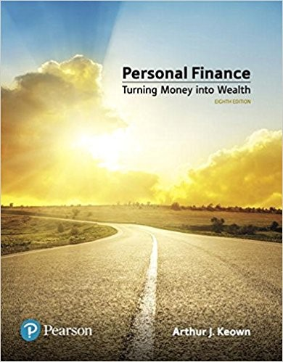
Personal Finance 8th edition by Keown
ISBNs MyFinanceLab and loose leaf text 9780134732053 or
MyFinanceLab with Etext 9780134830216

Course Description
This is an advanced course in Finance. Principles and concepts addressed in prior courses are incorporated. This course examines the financial planning process throughout the individual’s life cycle. It is intended to blend theory with appropriate application to create strategies for achieving successful personal financial plans based on individual goals and objectives. Characteristics, methods and tools for taxes, money management, insurance, investments, retirement, and estate planning will be addressed. 47 contact hours.
Course Objectives
1. The student will explain the principles and disciplines of the personal financial planning process.
2. The student will evaluate the methods, instruments, and strategies for personal credit and money management.
3. The student will analyze the principles of personal risk management, measures to assess risk exposure, and the application of insurance-based strategies to reduce risk.
4. The student will identify the role of capital market investment in the personal financial plan.
5. The student will illustrate the principles, instruments, and strategies for retirement and estate planning.

- My Schedule

Click below for schedule of due dates:
FIN 4140 Schedule spring mod 1 2022

- Course Requirements


Technology Requirements
This is a quantitative class and you will need to use Microsoft Excel OR a financial calculator.
Students should have regular access to a computer that is connected to the Internet. It is strongly recommended that students have a broadband (high-speed) internet connection such as DSL or a cable modem. When viewing online videos or taking online quizzes/tests and doing homework, students should have an internet connection that is stable and will not drop their connection. Students without a stable high-speed internet connection should consider making arrangements to use alternative means (i.e. St. Petersburg College library or a similar facility) where a stable high-speed internet connection is available. Please note student computer problems do not constitute an acceptable excuse for missing a submission deadline (procrastinating until the due date increases risks that students may miss or do poor on required submissions).
Students are responsible for making sure their computers are compatible to the system requirements. Internet browser use and settings, security and virus protection software settings, necessary plug-ins and software requirements, and other computer requirements today require students to assure the computer they are using for their studies will appropriately support these systems and course needs to be successful. Students should contact SPC Technical Support if they need further assistance to get anything in this course to run appropriately on their computer.
A standard file format has been devised to apply to all classes in the College of Business to support file compatibility, sharing, and commenting needs. Students are required to submit all assignments in Microsoft Office formats (Word, Excel and other Microsoft formats). Students can get access to MS Office (FREE) through MySPC (see http://www.spcollege.edu/microsoft). No other formats (such as .RTF, .WPS, .PDF, etc) will be accepted.
The college further provides full function student licenses of other Microsoft software too in MySPC. For example students can get Visio which could be beneficial to students in this course and Mac students can get Windows too. Details regarding obtaining Microsoft software licenses (FREE) are provided in MySPC under the Resources tab (go to Microsoft download area).
Students also have their Live@edu email accounts which offers MS Office (without needing MS Office on your computer), SkyDrive, and other resources (see http://www.spcollege.edu/pages/dynamic.aspx?id=1204) that may be helpful in classes.
Communications Policy
Students should always practice professional communications not only with their professor, but also with college administration and their peers in the course (disrespectful and disruptive students may be removed from the course and even suspended or expelled from the college). Blended students should silence or turn off all electronic devices during class meetings. Professional communications should be used at all times which includes using an appropriate subject in the title, as well as a greeting or salutation and closing signature in emails (not doing so is only suitable for family and friends). Please understand employers are asking SPC to work with students on netiquette to help students grow better communication skills needed for a successful career (see link for more tips).

Time Commitment
This is a 3-credit course conducted over 8 weeks. In order to meet accreditation standards, on average, students should expect to spend between 12 to 15 hours per week on course activities and assignments.
Course Prerequisites
FIN 3403 and Admission to: BUS-BS.

- Grading and Attendance


Grading Policy
This class uses a weighted average for final grades. There are 17 chapter homework assignments and a MFL orientation and a Review assignment included with the homework chapter assignments. Homework is worth 40 percent of your weighted average. There are 17 chapter quizzes. Quizzes are worth 20 percent of your weighted average. There are 4 tests. The 4 tests are worth 40 percent of your weighted average. In order to earn a A students must have a weighted average of 90% or greater; Bs 80% to 89.9%; Cs 70% to 79.9%; Ds 60% to 69.9% and Fs below 60%.
Attendance Policies:
As the syllabus addendum states, instructors will verify and report student attendance in the first two weeks. Students will be classified as ‘No Show’ if blended students do not attend their physical meeting or if online students do not provide any submissions for each week. Students with attendance issues in both Week 1 and 2 will be administratively withdrawn from the course and will receive a grade of W. As the syllabus addendum further states, students with financial aid will be responsible for paying for the class if they have an attendance issue these first two weeks.
To be successful students should complete all the assigned actions items and submissions as shown in the syllabus schedule. Furthermore since future weekly activities build on early weekly activities students will be more confident and successful if work is completed on time.
Further in the week following the last date to withdraw with a W (see academic calendar), instructors will report students who are not actively participating in the course. Students that have not completed the majority of the assigned graded submissions in Week 3 through Week 5 will be reported as not actively participating in the course and will receive a grade of WF in that following week. As the syllabus addendum states, students may withdraw themselves prior the last date for a W. Students should review this college-wide policy further to understand GPA and financial consequences.
No late submissions will be accepted unless the student provides a documented excuse (i.e. family death certificate, doctor's note, etc.). After verification of this documentation a late submission may be accepted as long as completed within one week from the due date. Advance notice should be given to the instructor whenever possible to arrange for further alternatives. Please note computer problems, travel, and lack of planning do not constitute an acceptable excuse for not meeting a deadline. Students should review the syllabus schedule and plan their time each week to complete the action items on-time (all deadlines are by 11:55PM EST).

